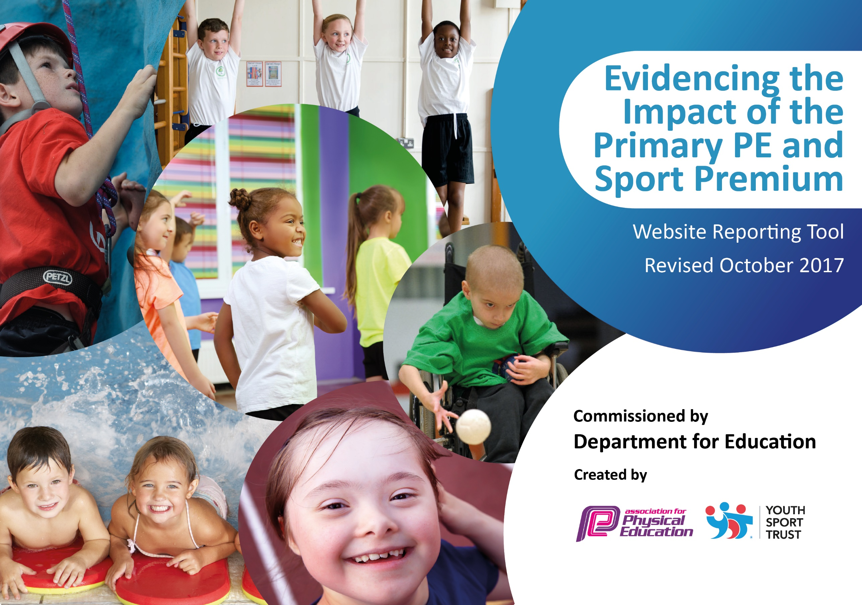

Summer Lane Primary School 2025-26



At Summer Lane Primary School we firmly believe that sustainable improvements to the quality of PE and sport is fundamental to developing outcomes for our pupils. We aim to use the Primary PE and Sport Premium to:
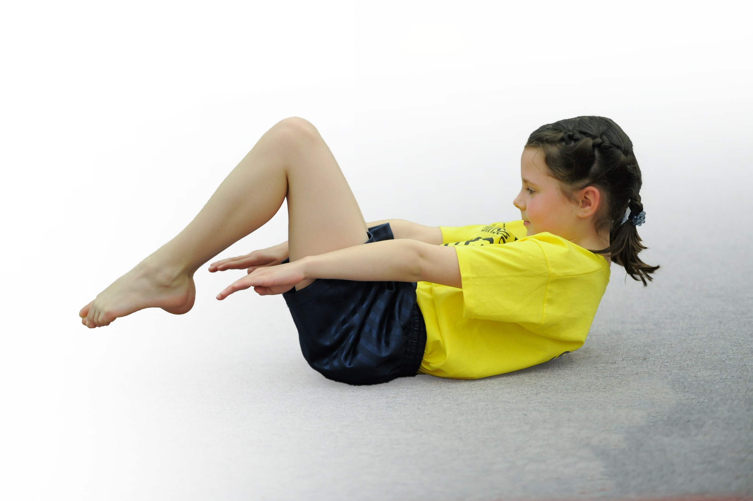
- develop or add to the PE and sport activities that your school already offers
- build capacity and capability within the school to ensure that improvements made now will benefit pupils joining the school in future years

We welcome the Sports Premium Grant to provide additional funding to improve provision of Physical Education (P.E) and sport in our school. The key areas for consideration are; Physical education, Healthy active lifestyle choices and Competitive sports.

Current achievement and priorities

Key achievements to date: | Areas for further improvement and baseline evidence of need:
As a result of sports funding the following have been evidenced through subject monitoring, lesson observations and learner discussion  - ALL children are encouraged to take part in competitive sports.  - Broad range of extra-Curricular sports clubs provided for EYFS, KS1 & KS2 children of all abilities before, during and after school.  - Increased participation in inter school sports competitions. The majority of children in KS2/KS1 attended a sporting competition this year.  - School attended XX sporting competitions this year.  - Fully inclusive sports programme.  - Specialist coaches upskill staff and there is now high-quality teaching and learning in PE being delivered by school staff.  - Purchased new sports equipment to improve the quality of children’s learning and development.  - HCAT Sports Event KS2.  - Sports Day 2025 – parents joined.  - Continuing to raise money for Barnsley Hospice through Rudolph Run.  - The use of lunchtime access to games through quality provision from Team Activ and BFC.  - Arbor has allowed teachers to track children’s progress in P.E and has allowed leaders to identify gaps.  - The development of the P.E curriculum alongside high quality planning has meant the teaching of P.E is at least good or outstanding.  - School achieved a gold school games mark. | - Further develop quality of teaching & learning of PE  - Further develop curriculum assessment and monitoring tool using Arbor and Seesaw for evidence.  - Use of MAT to develop sporting activities across schools with MAT.  - Continue using new long-term plan.  - Use of retrieval activities within topics to support retrieval.  - Further develop subject knowledge for all staff so that everyone feels comfortable scaffolding or challenging pupils in all areas of PE.

Meeting national curriculum requirements for swimming and water safety | Please complete all of the below:
What percentage of your Year 6 pupils could swim competently, confidently and proficiently over a distance of at least 25 metres when they left your primary school at the end of last academic year? | 45%
What percentage of your Year 6 pupils could use a range of strokes effectively [for example, front crawl, backstroke and breaststroke] when they left your primary school at the end of last academic year? | 35%
What percentage of your Year 6 pupils could perform safe self-rescue in different water-based situations when they left your primary school at the end of last academic year? | 85%
Schools can choose to use the Primary PE and Sport Premium to provide additional provision for swimming but this must be for activity over and above the national curriculum requirements. Have you used it in this way? | No

Action Plan and Budget Tracking

Academic Year: 2025/26 | Total fund allocated: £18,370 | Date Updated: Summer 2024
Key indicator 1: The engagement of all pupils in regular physical activity – Chief Medical Officer guidelines recommend that primary school children undertake at least 30 minutes of physical activity a day in school |  |  |  | Percentage of total allocation:
 |  |  |  | 20%
Intent | Implementation | Funding allocated: | Evidence and impact | Sustainability and suggested next steps:
- Specialist, high quality P.E teaching available to all children which covers a range of sports.  - Structured, targeted after and before school clubs offering a wide range of sports. Emphasis at increasing numbers of certain clubs.  - Play leaders at lunchtime support – lunch time activities. Dinner staff to also deliver sporting activities.  - Emphasis on sporting competitions motivates all children to partake in physical activities in school. | - Increase teaching staff confidence in delivering high quality P.E lessons through time with P.E leads. Access to high quality CPD through BFC.  - Teachers deliver quality extra-curricular clubs; a special focus is placed on the most disadvantaged pupils.  - P.E ambassadors trained up by sports leads to develop a range of sporting activities which can be delivered at lunch times on both the KS1 and KS2 playgrounds. P.E leads to deliver training to dinner staff.  - Regular reminders of upcoming competitions (external or internal) so children are motivated to partake in extracurricular sporting activities.  . | Internal  Internal  Internal  Internal |  | To ensure the sustainability of the initiatives and build upon the initial impact, the following steps will be taken:  a) Staff training and development:  - Continue to provide professional development opportunities for staff, focusing on enhancing their knowledge and skills in promoting physical activity.  - Encourage staff to share best practices and collaborate on innovative ideas to further engage pupils in regular physical activity.  b) Regular evaluation and review:  - Conduct regular evaluations of the implemented strategies to assess their effectiveness and identify areas for improvement.  - Use the feedback received from pupils, parents, and staff to inform future planning and decision-making.  c) Partnerships with local community:  - Strengthen partnerships with local sports clubs, organizations, and community facilities to provide ongoing opportunities for pupils to engage in physical activity outside of school.  - Explore potential joint initiatives and collaborative projects that promote physical activity and healthy lifestyles within the wider community.  By implementing these strategies, monitoring their impact, and ensuring sustainability through ongoing evaluation and collaboration, we aim to create a school environment where all pupils are actively engaged in regular physical activity, promoting their health and well-being.
Key indicator 2: The profile of PE and sport being raised across the school as a tool for whole school improvement |  |  |  | Percentage of total allocation:
 |  |  |  | 16%
Intent | Implementation | Funding allocated: | Evidence and impact: | Sustainability and suggested next steps:
- Sporting achievements celebrated in assembly to encourage physical activity both in and out of school.  - Develop P.E ambassadors/leaders to act as role models across school, supporting in P.E lessons and at lunch times.  - Sporting competitions through BPSP and BFC, with a focus on ensuring all children attends at least one competition across the school year.  - A focus on delivering high-quality P.E lessons which are well planned and sequence to ensure skills are progressive.  - Adapted tasks for pupils with SEND to ensure they can access the full curriculum in line with their peers.  - Children assessed half termly in P.E using Arbor/Seesaw to track progress.  - Children to partake in active breaks throughout the school day to enhance wellbeing.  - Sports coaches utilized to deliver specialist high quality P.E lessons alongside teachers to develop CPD and teacher skillset and extra-curricular activities.  - Children to take part in inter-school competitions. | - Friday celebration assembly to have a sport section where children can celebrate success.  - Grassroots to train P.E ambassadors so they are confident and skilled at delivering these sessions. Grassroots will continue to work and support throughout the year. Playground lead session ran by SGO to support P.E ambassadors.  - Teachers aware of competitions in their year groups and deliver high quality P.E lessons/deliver extra-curricular clubs to ensure children are ready for competitions.  - P.E observations and access to team teaching to support the delivery of lessons.  - P.E leads to meet with SENCO to devise a bank of adaptations to support children with SEND.  - P.E leads to monitor whole school P.E data through arbor/Seesaw to identify gaps and praise progress.  - A focus on active and collaborative learning from all teachers across the curriculum. Opportunities to take part in a daily mile.  - Sports coaches in targeted sports invited in to support teacher confidence and quality of lessons.  - Inter school competition pyramid set up with Gawber and St Mary’s PS. | Internal  External  External (competitions)  Internal  Internal  Internal  Internal  External |  | To ensure the sustainability of raising the profile of PE and sport across the school, consider the following:  a) Regular review and evaluation: Continuously review the impact of the strategies in place and make adjustments as necessary. Regularly assess the effectiveness of the curriculum, extracurricular activities, and staff development initiatives.  b) Secure funding: Explore different funding opportunities, such as applying for external grants or using the primary PE and Sport Premium funding, to sustain and enhance the provision of PE and sport in the long term.  c) Collaboration and partnerships: Forge partnerships with local sports clubs, organizations, or other schools to provide additional resources, expertise, and opportunities for students to participate in a wider range of sports and activities.  d) Next steps: Identify areas for improvement and set new targets for the coming year. Consider ways to further engage hard-to-reach groups, promote inclusivity, and continue to raise the profile of PE and sport across the school.

Key indicator 3: Increased confidence, knowledge and skills of all staff in teaching PE and sport is supported and sustained through CPD |  |  |  | Percentage of total allocation:
 |  |  |  | 14%
Intent | Implementation | Funding  allocated: | Evidence and impact: | Sustainability and suggested  next steps:
- Coaches invited into school to deliver high quality lessons alongside teachers and CPD to staff to upskill children and staff.  - CPD targeted across school to deliver sessions in areas of need identified on the P.E action plan.  - P.E Leads support to be offered across school to enhance the planning and delivery of lessons.  - The integration of Seesaw to evidence PE lessons will share best practice and enhance pupil provision leading to stronger knowledge/outcomes. | - Coaches targeted in certain sports and year groups to enhance the teaching of P.E through CPD.  - CPD through SDMs delivered across the year covering delivering P.E lessons effectively and monitoring P.E.  - P.E leads given time to work with staff across school to support in the planning of high-quality P.E lessons.  - Seesaw use CPD delivered and PE lead given time to review evidence online regularly providing feedback, following up with CPD where necessary. | Internal  External  Internal  Internal |  | To ensure the sustainability of the improved confidence, knowledge, and skills in teaching PE and sport, consider the following steps:  a) Embed CPD into the school culture: Make CPD an ongoing and sustained activity rather than a one-time event. Encourage staff to engage in continuous professional development and provide regular opportunities for learning and growth.  b) Review and update CPD plans: Regularly review and update the CPD plans based on staff feedback and changing needs. Stay informed about new research and best practices in teaching PE and sport and incorporate them into the CPD program.  c) Seek external support: Consider involving external experts or organizations to provide specialized training and support for staff. This can bring fresh perspectives and ensure access to the latest knowledge and techniques.  d) Share success stories: Celebrate and share success stories of staff members who have benefited from the CPD program. This will motivate others to actively engage in their professional development.  e) Monitor and evaluate progress: Continuously monitor and evaluate the impact of the CPD program on staff and student outcomes. Use the data collected to inform future CPD initiatives and make necessary adjustments to ensure sustained improvement.  Overall, the intent of increasing confidence, knowledge, and skills of all staff in teaching PE and sport through CPD can be achieved by implementing targeted strategies, measuring the impact, and ensuring sustainability through continuous improvement and support.
Key indicator 4: Broader experience of a range of sports and activities offered to all pupils |  |  |  | Percentage of total allocation:
 |  |  |  | 25%
Intent | Implementation | Funding  allocated: | Evidence and impact: | Sustainability and suggested  next steps:
P.E curriculum is broad and balanced, allowing children to explore a range of sports during their time at SLPS.  Extra-curricular after-school clubs are available linked to pupil voice. Targeted pupils are encouraged to join.  Equipment available to use so children can access a range of sports.  Regular competitions both internal and external available to motivate children to try new sports and activities.  Access to “come try events” ran by BFC/Team Activ to encourage more children to try new sports.  P.E ambassadors/leaders to lead activities at lunch times to expose other children to a broad range of sports and activities. | P.E leads worked with directors to ensure the curriculum was broad and balanced.  External coaches invited in to run after school clubs alongside teachers to ensure children have access to a wide range of sports.  P.E leads to organise bikeability sessions for those year groups.  P.E leads to take stock of equipment in the P.E cupboard, using the P.E curriculum to decide what needs ordering.  P.E leads to share competition calendar with teachers so they are aware which competitions are available to their year groups and can then share with their classes.  P.E leads to promote “come try events” to ensure all children have access to some form of sporting activity outside of school.  P.E leads to train P.E ambassadors/leaders so they are capable of running lunch time sessions. | Internal (directors external?  External and internal  External  Internal – Equipment  External  External  External |  | Sustainability and Next Steps: To ensure the sustainability of our efforts and continuous improvement, we will:  a) Monitor and Evaluate: We will regularly review and evaluate the impact of our strategies to assess their effectiveness in providing a broader range of sports and activities. This will help us identify areas for improvement and make necessary adjustments.  b) Staff Training: We will provide ongoing training and development opportunities for our staff to enhance their knowledge and skills in teaching a diverse range of sports and activities. This will ensure that the quality of instruction remains high and that pupils receive the best possible experience.  c) Long-Term Partnerships: We will establish long-term partnerships with local sports clubs and organizations to ensure the sustainability of opportunities for our pupils. This will enable us to continue offering a diverse range of sports and activities even after the Sports Premium funding period.  d) Seek Feedback: We will actively seek feedback from pupils, parents, and staff to gather suggestions and ideas for further expanding the range of sports and activities offered. This will help us tailor our provision to meet the evolving interests and needs of our pupils.  By implementing these strategies, monitoring their impact, and taking steps towards sustainability, we aim to provide a broader range of sports and activities to all our pupils, ensuring they have the opportunity to explore and excel in different areas of physical activity.
Key indicator 5: Increased participation in competitive sport is sustained throughout the year |  |  |  | Percentage of total allocation:
 |  |  |  | 25%
Intent | Implementation | Funding  allocated: | Evidence and impact: | Sustainability and suggested  next steps:
- Above 70% attendance at inter school competitions throughout the year.  - Continue to develop strong links with local schools through sporting events.  - Continue to develop links with schools in our trust through sporting events.  - Emphasis placed on sports day as a competitive sporting event (in-school competitions).  - Develop opportunities for inclusive competitions for SEN pupils to participate in inter and intra.  - Continue to maintain high parent participation/support in sporting events. | - P.E leads to share competition calendar with teachers. Teaching to be of a high quality so children are ready for sporting competitions.  - P.E leads to attend BPSP competitions regularly. P.E leads to consider running extra sporting events, additional to the BPSP calendar with local schools.  - P.E leads to look at organizing trust sporting events throughout the year.  - P.E leads to organise sports day and ensure it has a competitive focus for all children.  - P.E leads to work with SENCO to decide which sporting events children can access.  - Sporting events to continue being shared with parents to ensure the link remains. | External  External – £2990  Internal  Internal  Internal  Internal |  | To sustain the increased participation in competitive sport, the following steps can be taken:  a) Regular evaluation and review: Continuously evaluate the effectiveness of the implemented strategies by gathering feedback from students, staff, and parents. Identify any areas for improvement and make necessary adjustments to ensure sustained engagement.  b) Professional development for staff: Provide ongoing training and professional development opportunities for staff members involved in delivering sports activities. This will ensure they have the necessary skills and knowledge to maintain the quality of provision.  c) Continued collaboration with local sports clubs: Maintain the partnerships with local sports clubs and organizations to provide ongoing opportunities for students to engage in competitive sports outside of school.  d) Celebrating achievements and promoting role models: Recognise and celebrate the successes of students and teams in competitive sport. Invite local sports personalities or successful alumni to share their experiences and inspire students to continue their participation in sports.  e) Review and update the Sports Premium action plan annually: Regularly review the impact of the Sports Premium funding and update the action plan accordingly. This will ensure that the strategies remain relevant and effective in achieving the intended outcomes.

