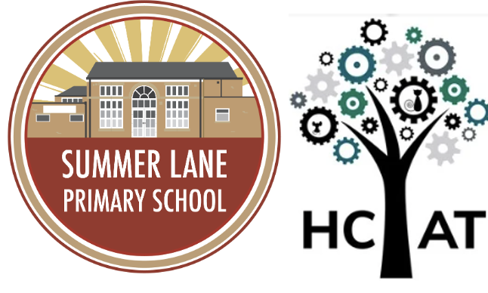

Behaviour Policy

Version Number | Version Description | Date of Revision
1 | Original | September 2025

Summer Lane Primary Behaviour Policy
Review Date: September 2027
At Summer Lane Primary, we believe that good behaviour is the key to a good education. We provide calm, safe and supportive environments which children want to attend and where they learn and thrive. We work to create a learning environment where everyone feels valued, secure and motivated; building positive relationships with pupils and carers. If a behaviour policy is to be effective, it is vital that it reflects the school vision and values and is consistently applied throughout school with strategies are in place to support children and staff:
ADD VALUES/VISION/ RULES

This policy has been written to comply with section 89 of the Education and Inspections Act 2006
Aims of the Policy
- To encourage respect for religious and moral values and tolerance of other cultures in a multi-racial society
- To develop the core courtesy and good manners and teach respect for themselves, others, and property and to develop a caring and responsible attitude towards our environment
- To help pupils appreciate the achievements and aspiration of all and celebrate their successes
- To ensure continuity and progression through effective behaviour strategies
- To ensure a consistent approach to behaviour management throughout the school
- To develop positive attitudes to learning objectives

This policy sets out to:
- Provide clear boundaries that children, staff and parents understand in relation to Summer Lane Home-School Agreement
- Meet the needs of pupils who have emotional and behavioural difficulties
- Promote a positive learning environment for all learners
- Ensure a common approach to behaviour management throughout school

School Rules and Values
Summer Lane Primary School has created core values and behaviour guidelines following consultation with the whole school. These are displayed around school and shared with children on a regular basis through lessons, assemblies, circle times etc. These have been shared with parents through the Home School Agreement. All classes have class agreements that are linked to learning behaviours in the class which have been created by children and staff.
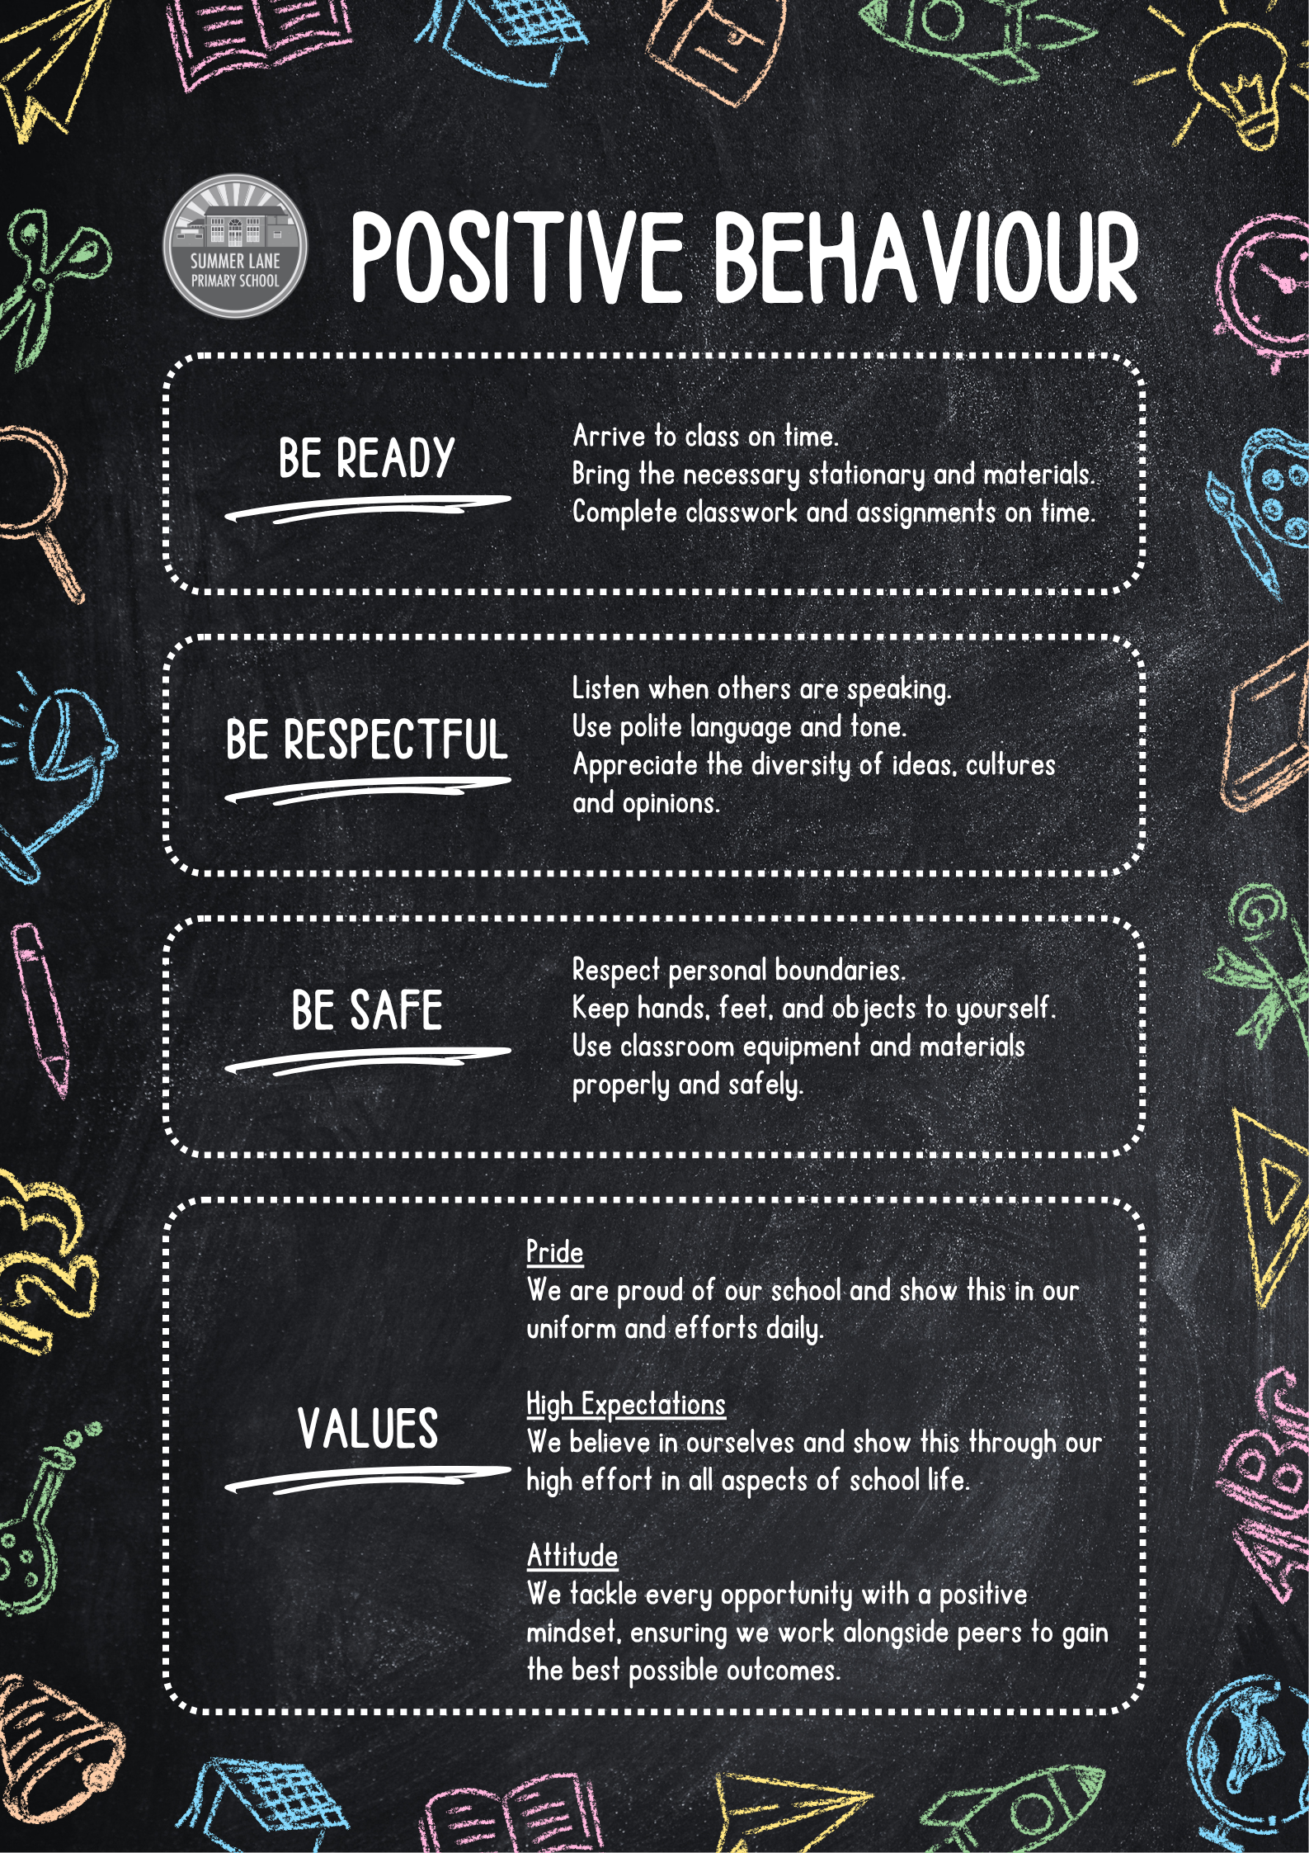

Classroom Management
We have high expectations of pupils’ behaviour at all times and believe that high quality teaching is key to ensuring positive attitudes towards learning. The school has a well-developed whole school approach to effectively managing behaviour of all pupils. We firmly believe that every member of our school community has a responsibility to teach children socially acceptable behaviour, ensuring that values and attitudes are promoted, and social norms and routines are encouraged throughout the school community. Through Personal Development & RSHE lessons, pupils are taught explicitly what good behaviour looks like; with a focus on modelling positive behaviours and outlining unacceptable behaviours.
Our behaviour system is built on positive relationships between staff and pupils with an understanding of children’s backgrounds and previous experiences. Positive descriptive praise and unconditional positive regard are the basis of our behaviour management system. We are aware that some pupils may require additional support to reach the expectations for behaviour and in such instances, support is identified, and preventative strategies implemented. Where behaviour presents from a SEND need, provision will be specifically referenced in the child’s SEN plan. In instances of unacceptable behaviour, action is taken promptly and consistently.
All staff will:
- Explicitly teach what good behaviour looks like
- Reward or re-direct children by referring to our core values & behaviour guidelines.
- Collect and greet children at the start of the day and after each break.
- Model positive behaviours and build relationships
- Acknowledge and reward children meeting our high expectations through phone calls home, Time to Shine certificates, praise postcards etc.
- Never ignore children who are failing to meet expectations
SMSAs will:
- Be friendly and approachable
- Be aware of relevant and accepted expectations and reinforcing them
- Be consistent and fair when giving rewards or imposing agreed sanctions
- Know the children as individuals, recognising their characters and taking this knowledge into account when working with them
- Support children’s development of behaviour skills and self-regulation, with training support
- Have high expectations observing children and informing class teachers and/or the head teacher about specific incidents or trends in behaviour
- Encourage respectful attitudes for others, the environment, property and equipment
- Support children with SEMH using agreed strategies
The Head teacher and The Senior Leadership Team will:
- Meet and greet children at the start of the day
- Be a visible presence around the school
- Regularly celebrate children whose efforts go above and beyond expectations
- Encourage use of positive praise, phone calls, values cards and certificates
- Support teachers in managing children with more complex or challenging behaviours
- Review provision for children who fall beyond the range of written policies.
Parents will:
- Work in partnership with school to ensure consistent messages are given about expected behaviours
- Support the school’s rules and policies
- Always make their child aware of appropriate behaviour.
- Inform school about any issues at home that might affect a child’s learning or behaviour

Pupils will:
- Work to the best of their abilities and allow others to do the same.
- Treat others with respect.
- Comply with the instructions of all members of staff.
- Take care of the school property and environment.
- Cooperate with other children and adults.
A consistent approach
Members of staff who manage behaviour well:
- Follow the in-school behaviour policy and consistently refer to school rules and values
- Deliberately and persistently catch children doing the right thing and praise them in front of others
- Know their classes well and develop positive relationships with all children
- Relentlessly work to build mutual respect and relationships
- Demonstrate unconditional care and compassion ‘deliberate botheredness’
Behaviour and Sanctions
Snip of Levelled behaviours
All staff have a statutory authority to discipline pupils whose behaviour is unacceptable, who break the school rules or who fail to follow a reasonable instruction. If a child breaks a rule this will be discussed with the child at an age-appropriate level. When poor behaviour is identified, sanctions are consistently and fairly implemented.
When there are problems with behaviour we aim to try and understand the reasons for it so that we can deal with it most effectively. It is important to label the behaviour as the problem and not the child. If misbehaviour or bullying does occur, then the type of action taken depends on the problem.
If there is still a continuation of poor behaviour a formal meeting will be held with the class teacher, head teacher, parent and child. The Home School Agreement will be referred to and discussed. At this meeting, targets will be agreed upon for child, home and school to work upon. In the most severe cases an individual behaviour plan, IBP, will be drawn up and a record of positive and negative behaviour will be kept. This will be sent home for the parent to sign and comment on, as necessary. Minutes of this meeting will be recorded and placed on the CPOMs system. A further meeting will be held if appropriate, the school SENDCO will attend this meeting to identify if there is any Special Educational Need.
If not resolved, fixed term suspension procedures will be initiated in accordance with Barnsley LA procedure. Severe behaviour issues e.g., violence towards another pupil or adult in school may result in the immediate suspension of the pupil. (See Barnsley LA guidance document Exclusion Procedure for further details). If the Head teacher excludes a chid s/he will inform parents immediately giving a clear reason.
It is important to remember the importance of a fresh start. Where incidents have escalated there needs to be some restorative work to rebuild relationships whether that be between adult and pupil or pupil and pupil.
Recognising the significance of SEND on behaviour
The school recognises that pupils’ behaviour may be impacted by a special educational need or disability (SEND). When incidents of misbehaviour arise, we will consider them in relation to a pupil’s SEND, although we recognise that not every incident of misbehaviour will be connected to their SEND. Decisions on whether a pupil’s SEND had an impact on an incident of misbehaviour will be made on a case-by-case basis. When dealing with misbehaviour from pupils with SEND, especially where their SEND affects their behaviour, the school will balance their legal duties when making decisions about enforcing the behaviour policy.
The legal duties include:
• Taking reasonable steps to avoid causing any substantial disadvantage to a disabled pupil caused by the school’s policies or practices (Equality Act 2010)
• Using our best endeavours to meet the needs of pupils with SEND (Children and Families Act 2014)
• If a pupil has an education, health and care (EHC) plan, the provisions set out in that plan must be secured and the school must cooperate with the local authority and other bodies
As part of meeting these duties, the school will anticipate, as far as possible, all likely triggers of misbehaviour, and put in place support to prevent these from occurring. Any preventative measures will take into account the specific circumstances and requirements of the pupil concerned.
In order to anticipate and remove triggers of misbehaviour, our approach includes examples such as: • Short, planned movement breaks for a pupil with SEND who finds it difficult to sit still for long
• Adjusting seating plans to allow a pupil with visual or hearing impairment to sit in sight of the teacher
• Adjusting uniform requirements for a pupil with sensory issues or who has severe eczema
• Training for staff in understanding additional needs
• Use of separation spaces (sensory zones or nurture rooms) where pupils can regulate their emotions during a moment of sensory overload
Adapting sanctions for pupils with SEND
When considering a behavioural sanction for a pupil with SEND, the school will take into account:
• Whether the pupil was unable to understand the rule or instruction?
• Whether the pupil was unable to act differently at the time as a result of their need?
• Whether the pupil is likely to behave aggressively due to their particular need?
If the answer to any of these questions is yes, it may be unlawful for the school to sanction the pupil for the behaviour. The school will then assess if it is appropriate to use a sanction and if so, whether any reasonable adjustments need to be made to the sanction.
Considering whether a pupil displaying challenging behaviour may have unidentified SEND
The school’s special educational needs co-ordinator (SENCO) may evaluate a pupil who exhibits challenging behaviour to determine whether they have any underlying needs that are not currently being met. Where necessary, support and advice will also be sought from specialist teachers, an educational psychologist, medical practitioners and/or others, to identify or support specific needs. When acute needs are identified in a pupil, we will liaise with external agencies and plan support programmes for that child. We will work with parents to create the plan and review it on a regular basis.
Pupils with an education, health and care (EHC) plan
The provisions set out in the EHC plan must be secured and the school will co-operate with the local authority and other bodies. If the school has a concern about the behaviour of a pupil with an EHC plan, it will make contact with the local authority to discuss the issue. If appropriate, the school may request an emergency review of the EHC plan.

Restorative Discussions
Following a sanction, the school will consider strategies to help pupils to understand how to improve their behaviour and meet the expectations of the school.
Following any kind of disagreement or breach of school rules all parties take part in a restorative discussion.
• Everyone must be given enough time to calm down before the restorative discussion takes place.
• Pupils can conduct the restorative discussions themselves depending on their age, and the severity of the disagreement. Otherwise, it must be an adult that was involved in the incident who supports with the discussion.
• All members of staff and children know that issues will be dealt with fairly with a ’no blame’ approach, and the language used in discussions is fair, consistent and respectful.
• Discussions are held in a calm, quiet, private place.
In Foundation stage, staff model good behaviour, manners and a positive attitude towards each other. Routines, boundaries and high expectations are consistently reinforced by all staff in the setting. Foundation stage staff will verbally feedback to parents/carers at the end of each session to resolve, inform about, or discuss behavioural issues further.
In the case of more serious issues, Foundation stage staff will follow the same procedures as set out for the rest of school.
Pupil transition Inducting incoming pupils
The school will support incoming pupils to meet behaviour standards by offering an induction process to familiarise them with the behaviour policy and the wider school culture.
Preparing outgoing pupils for transition
To ensure a smooth transition to the next year, pupils have transition sessions with their new teacher(s). In addition, staff members hold transition meetings. To ensure behaviour is continually monitored and the right support is in place, information related to pupil behaviour issues may be transferred to relevant staff at the start of the term or year.
Playtime Supervision
All pupils will be escorted to and from the playground to ensure they start playtime in a calm manner. When on duty, staff should circulate and take the opportunity to socialise with children from other classes, whilst maintaining an overview of the play area and spotting potential problems before they escalate. Staff should avoid standing chatting to each other and consider their own positioning to maximise levels of visual supervision. If a rule is broken at break or lunch time, staff on duty will deal with accordingly, if appropriate, staff will communicate this to the class teacher who will deal with the issue in line with the steps above. SMSAs report back to the class teacher at the end of lunchtime.
Breakfast club
All children are invited to attend breakfast club, although children are free to choose from the range of activities available, we expect them to abide by the school rules at all times. In the case of severe breaches of these rules, the offer of a place may be withdrawn.

Extra-Curricular activities and clubs
All children are invited to choose from a variety of clubs to enrich their learning experiences. All children attending will be expected to follow the school rules at all times. In the case of severe breaches of these rules, the offer of a place may be withdrawn.
School Trips
Where children’s inappropriate behaviour results in them being unable to attend planned school trips/visits due to them posing a threat to the safety of themselves or others i.e., absconding, refusal to follow directions from staff or aggression towards others, parents will not be offered refunds for any monies paid and will accept this is a consequence of their child’s behaviour in school. Each case will be decided upon individually according to circumstances and the parents will be informed as soon as possible. Where a child is unable to attend such trips/visits, as a consequence of their behaviour, alternative educational activities will be planned in school. Children are still expected to attend school and parents have a legal responsibility to make sure they do as set out under our attendance policy and in line with Government requirements.
Serious Incidents
A serious incident such as threats, violent and aggressive behaviour or swearing maliciously, refusal or defiance needs to be reported to a member of SLT immediately. Parents will be informed of all serious incidents. Appropriate consequences will be issued by SLT. If required, exclusion procedures will be initiated in accordance with Barnsley LA procedure (See Barnsley LA guidance document Exclusion Procedure for further details).
Rewards and Privileges
Summer Lane Primary School recognises the importance of positive descriptive praise when promoting positive behaviour. The school adopts a range of reward systems in order to encourage positive behaviours to learning, but also recognises that intrinsic rewards are key to promoting a culture of positive behaviours for learning. We also firmly believe in a culture of unconditional positive regard.
Points Mean Prizes
Summer Lane runs a points system in school. Pupils can receive points for demonstrating positive learning behaviours, achievements, following school rules and exhibiting core values. These are totalled and certificates are given for achieving milestones. A points shop may be visited for 30 points being earned. Pupils who are top points earners in school can spin the prize wheel as can the top scoring class every so often. These will be prizes they can have within school time. A 150 club will be for any pupil receiving 150 points or more and a trip or event will be held to reward these pupils.
Children are encouraged through individual class praise and rewards e.g., through the use of verbal and written praise, stickers, postcards and other certificates.
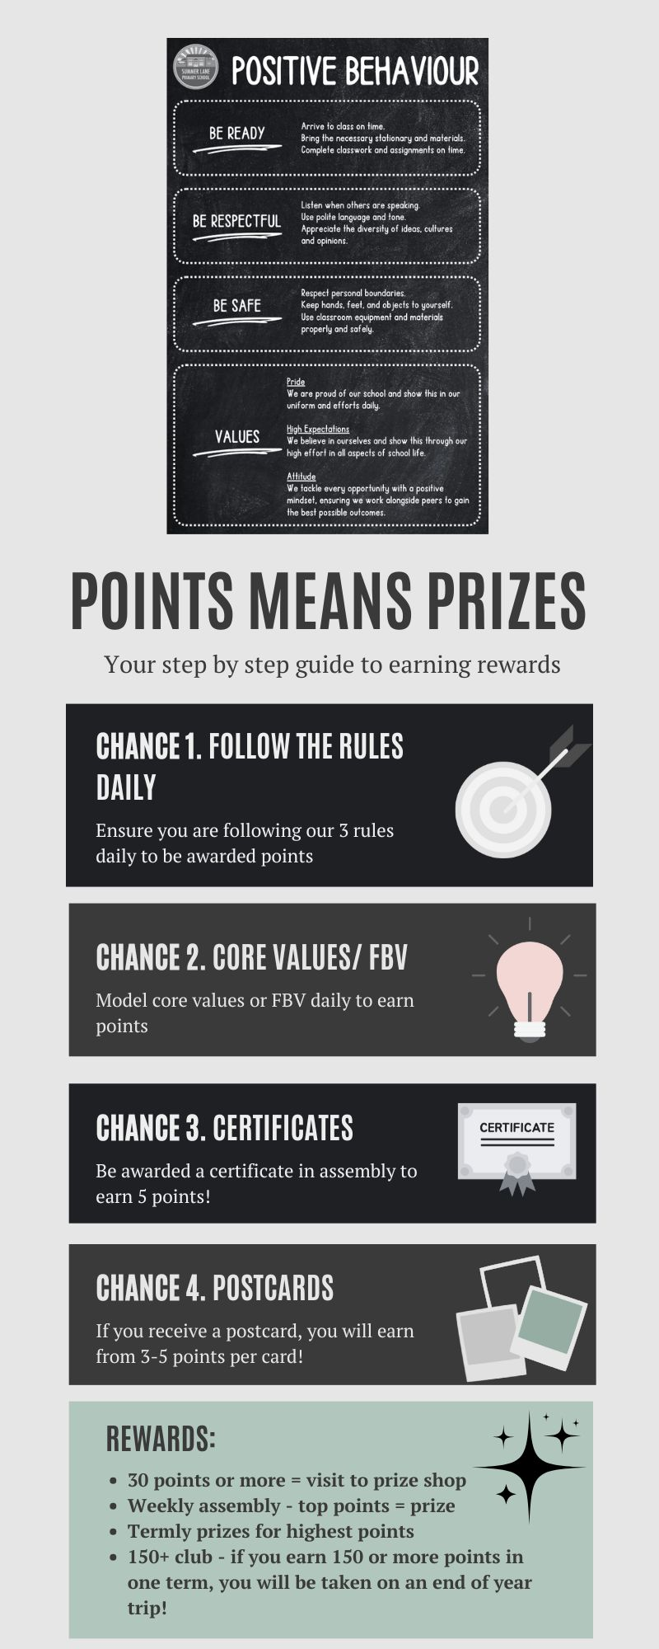

Parental Involvement
It is vital that parents are kept informed of strategies used to help support the behaviour of pupils. Parents are expected to support staff in decisions made in order support the improvement of behaviour and keep in regular contact with the teacher involved. Parents are encouraged to discuss any issue related to behaviour, either in school or at home. Parents will be informed if a child is regularly not behaving in line with the school rules. If the problem is severe parents will be contacted on the first occasion (for example violent or racist behaviour). The Summer Lane Home-School Agreement forms the basis of the expected behaviour of pupils in school and the roles of both parents and staff to uphold this agreement. The Home-School Agreement will be reviewed and sent out to parents annually. In severe circumstances, parents may be asked to remove their child from the premises at lunchtimes and alternative arrangements will need to be made.
Managing Behaviour over time: The head of school & SLT monitor patterns of behaviour half termly. Parents will be contacted at any point if their support is deemed necessary, and to inform them of particular incidents. Classroom staff should inform the headteacher of steps already taken and seek support as soon as they realise that strategies are not bringing about rapid improvements. Generally, the class teacher retains responsibility for managing behaviour of children in their class.
Strategies implemented by class teachers, teaching assistants and mid-day supervisors would include: ● Positive reinforcement through reminders of expectations in line with the values of the school
● Awarding points in recognition of compliance with school expectations.
● Supporting conflict resolution by mediating with children; encouraging children to talk and explain what has happened, helping them to see how conflict has occurred and to support children to find a resolution agreeable to all parties.
Recording and reporting Behaviour incidents will be systematically recorded using Arbor to identify patterns of behaviour. By taking the action of recording incidents of behaviour we are giving a clear message to parents, staff, and the wider community that we take these incidents seriously and can become essential evidence if there is a dispute between the parties about how an incident has been handled.
The school leadership team will be responsible for overseeing all recorded behaviour incidents and adding appropriate actions where necessary. Behaviour reported to SLT will also be recorded to Governors as part of the Head Teacher’s Report. All behavioural incidents are dealt with on a case-by-case basis and in conjunction with our Safeguarding Policy, Anti Bullying Policy, Mental Health Policy and SEND code of practice.
Bullying
Bullying is defined as the repetitive, intentional harming of 1 person or group by another person or group, where the relationship involves an imbalance of power.
Bullying is, therefore:
• Deliberately hurtful
• Repeated, often over a period of time
• Difficult to defend against

TYPE OF BULLYING | DEFINITION
Emotional | Being unfriendly, excluding, tormenting
Physical | Hitting, kicking, pushing, taking another’s belongings, any use of violence
Prejudice-based and Discriminatory, including:  Racial  Faith-based  Gendered(sexist) Homophobic/biphobic; Transphobic;  Disability-based | Taunts, gestures, graffiti or physical abuse focused on a particular characteristic (e.g. gender, race, sexuality)
Sexual | Explicit sexual remarks, display of sexual material, sexual gestures, unwanted physical attention, comments about sexual reputation or performance, or inappropriate touching
Direct or indirect verbal | name-calling, sarcasm, spreading rumours, teasing
Cyber-bullying | Bullying that takes place online, such as through social networking sites, messaging apps or gaming sites.
Details of our school’s approach to preventing and addressing bullying are set out in our anti-bullying policy.
Child on Child Abuse
The school will ensure that all incidents of sexual harassment and/or violence are met with a suitable response, and never ignored. Pupils are encouraged to report anything that makes them uncomfortable, no matter how ‘small’ they feel it might be.
The school’s response will be:
• Proportionate
• Considered
• Supportive
• Decided on a case-by-case basis
The school has procedures in place to respond to any allegations or concerns regarding a child’s safety or wellbeing.
These include clear processes for:
• Responding to a report
• Carrying out risk assessments, where appropriate, to help determine whether to:
- Manage the incident internally
- Refer to early help
- Refer to children’s social care
- Report to the police
Please refer to our child protection and safeguarding policy for more information.

Malicious allegations
Where a pupil makes an allegation against a member of staff and that allegation is shown to have been deliberately invented or malicious, the school will consider whether to discipline the pupil in accordance with this policy.
Where a pupil makes an allegation of sexual violence or sexual harassment against another pupil and that allegation is shown to have been deliberately invented or malicious, the school will consider whether to discipline the pupil in accordance with this policy. In all cases where an allegation is determined to be unsubstantiated, unfounded, false or malicious, the school (in collaboration with the local authority designated officer (LADO), where relevant) will consider whether the pupil who made the allegation is in need of help, or the allegation may have been a cry for help. If so, a referral to children’s social care may be appropriate. The school will also consider the pastoral needs of staff and pupils accused of misconduct. Please refer to our child protection and safeguarding and sexual harassment and violence policy for more information on responding to allegations of abuse against staff or other pupils.
LEA Support and Outside Agencies
Summer Lane Primary School cannot always resolve problems which are linked to wider social issues. At times, the school may need to contact outside agencies for support with these issues. Children with behavioural issues may require support from other agencies, including support for parents. Children with SEN and Disabilities, in the case where a pupil’s behaviour is affected by a SEN or disability, the school behaviour policy will be followed as closely as possible. However, there may be occasions where the school has to take alternative actions or arrangements to suit the needs of the individual with the need/disability.
As professionals, we recognise that there is a close link between content and delivery of the curriculum and pupil behaviour. We aim to ensure that our teaching and learning is enjoyable, challenging and personalised to ensure that all pupils demonstrate positive attitudes towards learning. For further guidance, see DFE publication Behaviour and Discipline in Schools (January 2016); Behaviour in schools (Sep 22) and Section 89 of the Education and Inspections Act 2006.
Training
As part of their induction process, our staff are provided with regular training on managing behaviour, including training on:
• The proper use of restraint (where appropriate)
• The needs of the pupils at the school
• How SEND and mental health needs impact behaviour
Behaviour management will also form part of continuing professional development sessions and the school subscribe to The National College, which has a programme of CPD provided around behaviour that staff are expected to complete as part of their continuing professional development.
Possession of Prohibited Items
Any prohibited items (listed below) found in a pupil’s possession as a result of a search will be confiscated. These items will not be returned to the pupil.
• Knives or weapons
• Alcohol
• Illegal drugs
• Stolen items
• Tobacco and cigarette papers
• Fireworks
• Pornographic images
• Any article a staff member reasonably suspects has been, or is likely to be, used to commit an offence, or to cause personal injury to, or damage to the property of, any person (including the pupil)
We will also confiscate any item that is harmful or detrimental to school discipline. These items will be returned to pupils after discussion with senior leaders and parents, if appropriate.
Additional notes
Additional guidance, DfE’s publication of guidance
Power to use reasonable force - Members of staff have the power to use reasonable force to prevent pupils committing an offence, injuring themselves or others, or damaging property, and to maintain good order and discipline in the classroom.
1. The term ‘reasonable force’ covers the broad range of actions used by most teachers at some point in their career that involve a degree of physical contact with pupils.
2. Force is usually used either to control or restrain. This can range from guiding a pupil to safety by the arm through to more extreme circumstances such as breaking up a fight or where a student needs to be restrained to prevent violence or injury.
3. ‘Reasonable in the circumstances’ means using no more force than is needed.
4. As mentioned above, schools generally use force to control pupils and to restrain them. Control means either passive physical contact, such as standing between pupils or blocking a pupil's path, or active physical contact such as leading a pupil by the arm out of a classroom.
5. Restraint means to hold back physically or to bring a pupil under control. It is typically used in more extreme circumstances, for example when two pupils are fighting and refuse to separate without physical intervention.
6. School staff should always try to avoid acting in a way that might cause injury, but in extreme cases it may not always be possible to avoid injuring the pupil.
Staff must always inform a member of the SLT if restraint has taken place. Additional guidance, following the DfE’s publication of updated guidance in 2016.
Headteachers and teachers were also given the power to discipline pupils for misbehaving outside of the school premises “to such an extent as is reasonable” (Para 21, Section 90 of the Education and Inspections Act 2006)
- misbehaviour when the pupil is
o taking part in any school-organised or school related activity
o travelling to or from school
o wearing school uniform
o or is in some other way identifiable as a pupil of the school
- misbehaving at any time, whether or not the conditions above apply, that
o could have repercussions for the orderly running of the school or
o poses a threat to another pupil or member of the public or
o could adversely affect the reputation of the school.
This policy has been written in line with Behaviour in Schools Advice for headteachers and school staff, September 2022.

